**Ideation Phase**

**Define the Problem Statements**

|  |  |
| --- | --- |
| Team ID |  |
| Project Name | Inventory management system for retailers |

**Customer Problem Statement Template:**

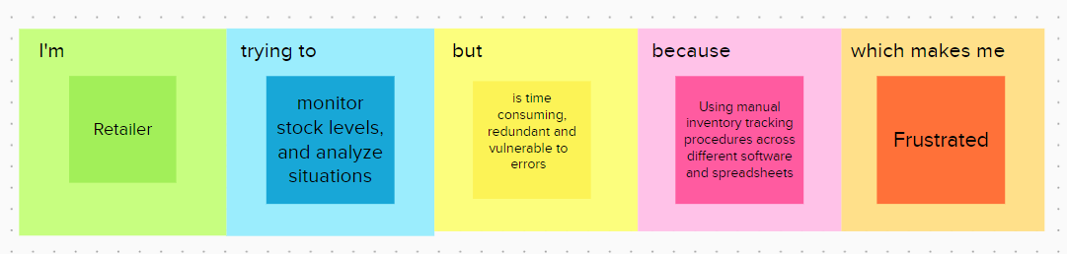

|  |  |  |  |  |  |
| --- | --- | --- | --- | --- | --- |
| **Problem**  **Statement (PS)** | **I’m** | **trying to** | **But** | **Because** | **Which makes me feel** |
| PS-1 | Retailer | monitor stock levels, and analyze situations effectively, avoid out of stock situations,avoid overstocking, retain customers | is time consuming, redundant and vulnerable to  errors | Using manual inventory tracking procedures across different software and spreadsheets. | Frustrated, stressed and sad |